About True Volunteerism – A Sincere Account of Bátor Tábor

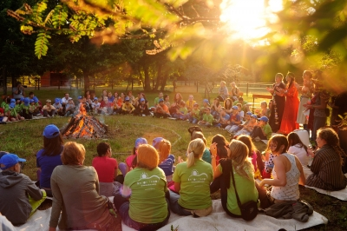

The Camp has left a very powerful impression on the author of Éva Magazine; below is an uplifting confession!
I have always believed about volunteerism that people who decide to do such a thing are mainly doing it for their own sake; they are trying to rescue themselves, and the means to do so is through helping others. The reason I thought so was because I was one of them. I have volunteered to paint the walls of the schoolhouse, organized various events, and I even spent a few months in Sri Lanka. The common theme in these adventures was that without exception they were all prompted by a problem in my life needing a solution, and I expected some help or at least some impulse from volunteering which would help me to solve the problem. This does not diminish the value of the matter; in fact, this method has proven to be effective, because by devoting my attention to someone else, my focus has shifted from my own problem to that of someone else's, which automatically brought about the solution to my own. So, this was the ultimate win-win situation.
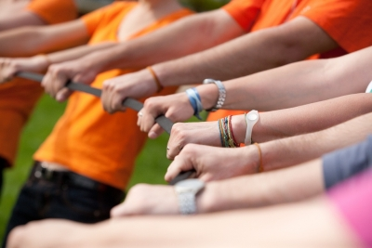
Over the past few weeks, for the first time in my life I took the path of a volunteer for reasons other than something personal. I was stable and balanced when I set out to visit Bátor Tábor, led not by a problem to be solved but by curiosity. I simply wanted to know why this Camp is getting so much praise; how it is possible to work with children with chronic diseases; how it is possible to perform well at a brand new place, with new people, in a new role; whether I will find it trying to deal with sick children; whether therapeutic recreation works; and so on. All I wanted was to find answers to these questions, but it will be difficult to describe how much more I have gained; yet, I will give it a try.
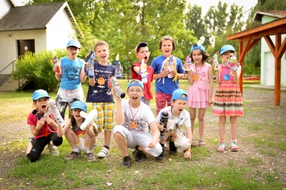
Imagine that there is a world where there is love and constant tranquility; where everyone accepts one another the way they are. Where there are no assumed roles or masks; where everyone can be themselves. Where you are approached with love and where everything is about the children and about making the one week they spend at the Camp unforgettable. The volunteers arrive a few days before the children so that they can get ready to receive them. We spent days learning games, studying the programs offered to them and cutting out figures from colored paper; bears, wild mushrooms, birds, butterflies. Suddenly we were taken back to our childhood where everything is colorful, even the ordinary is exciting, and there are no conventions or, if there are, they are different from those in the adult world. One evening, while we were drawing a giant fox on cardboard so that we could cut it out later and color it, I tried to recall the last time I had done something like this but, of course, I failed. This is somehow natural; most people - not counting those lucky few in certain professions, once they are grown up don't draw foxes. When it came to coloring, it was obvious that we should color the animal red, since foxes are red. I put down the marker at this point, because all of a sudden I came to a realization! That is, how boring I am. Why should a fox be red? A fox can be any color! In fact, it can be a number of different colors! This is how we have come up with a blue fox and a great discovery; the trouble with grownups is that they have forgotten what it was like to be a child.

As adults, we live surrounded by rules; we constantly adapt our behaviors to something; we try to measure up to our family, our partner, our boss, our coworkers. And in trying so hard to conform, we often lose what is really important: ourselves and our creativity. With the blue fox I have entered the fantasy world that I still refuse to break away from even now that the Camp is over. There, for many days we played, sang, danced, played hide and seek in the woods, marched in fairy costumes. Bátor Tábor is about allowing children with chronic diseases - who at times spend months or even years going through hospital treatment - to experience the many things they are capable of. It doesn't matter if some are living with prostheses or bound to a wheelchair; with the help of the Camp volunteers or 'Buddies' as they are called there, they are just as able to practice dancing, archery, rowing or balancing on a several meter high rope course as their able-bodied peers. The children step out of their comfort zones during these activities to rediscover what they had lost because of their disease; their strength, their courage, their faith in themselves.
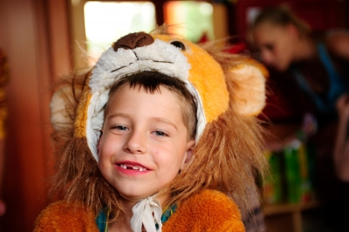
In a tucked-away corner of my mind I have known it all along that the world outside still exists just as it has before, but I've also realized that there is a spot on the glove where the important real things happen. Outside, people rush around, worked up, negotiating and producing documents; and in here sick children catch giant fish, climb up high, and exceed their own limits over and over again.
And what is true volunteerism? When it doesn't matter how bad your headache is, you still smile at the child next to you. When you know that a very important message is waiting on your phone but you only check it after the children have gone to bed, because you know that if you read it first, it will occupy some of your thoughts and you will have less energy for the children. True volunteerism is when you do it for others, not for yourself; when you have but one goal: to do good for others. And you can only do this if you are doing well yourself. If you have enough energy, smiles and stability, you are able to share some of it with others. This, of course, is good for you, too – if it wasn't, it wouldn't work.
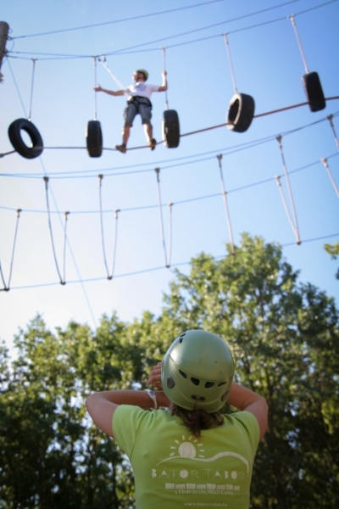
I thought about it a lot, why this was so good for me. I concluded that it was because my two deepest fears - which are the same fears most people have - disappeared 100% at the Camp. These fears are formed along the lines of two questions; 'Am I loved?' and 'Am I being useful?' Everyone desires to be loved and accepted, and to have an impact on others, to leave a lasting impression. Bátor Tábor creates an environment where buddies and children alike accept one another just the way they are; everyone turns to the others with love, for although we are different, our goal is the same. And there is no question about it that the Camp leaves a lasting impression on the children. And I don't just mean the follow-up that the foundation behind the Camp does on the children's fate afterwards or the research to find evidence that therapeutic recreation has a long-term effect, but also that continued interaction with the buddies, lots of laughter, costumes and nursery rhymes are just as important as whether the child climbs the high rope course or not. The most memorable moments of my childhood are not necessarily those tied to the greatest events. Tiny moments that may have seemed insignificant at the time get imprinted in our minds and become part of our personality. This could be a motion, a gesture, a book we enjoy, but also something seemingly insignificant, such as a blue fox.
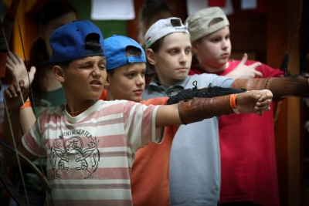
For me, Bátor Tábor is a wonderful fantasy world, a Kosztolányi poem spanning across ten days, and once we have become part of it, we will never want to live without it again. And what will I take home with me from the Camp? First of all, that everything is possible, once there is a will. Secondly, that we must always seek out situations and people where and with whom we can be ourselves. If you are feeling light and able to give yourself, then you are also able to make an impact on others, and there is no greater gift than this. Thirdly, that the comfort zone is a good thing, but it is even better if you are looking back at it from the outside. You must rise up high even when you are afraid; you must hold the other person's hand even when you never have trust; and you must row the boat even when you have no hands, because you can do it and you are able to do it. And if you can't do it alone, there will always be someone there to help you, because people are essentially good, they just need to be given the opportunity to show it.

